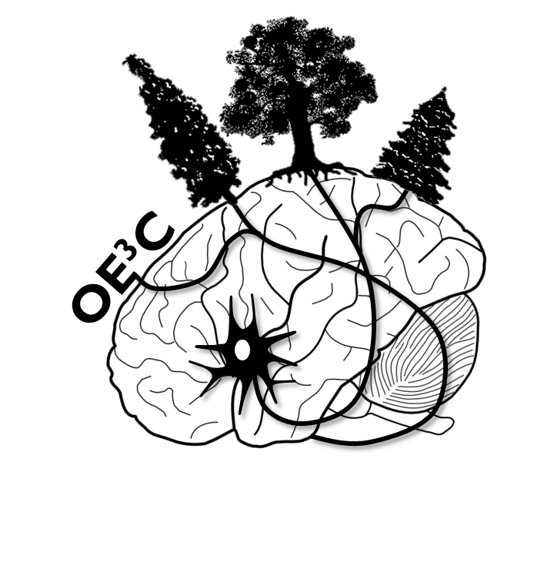

Dear York University Students:

The Ontario Ecology, Ethology, and Evolution Colloquium (OE3C) is an annual conference that takes place at a different university in Ontario each year. The meeting is organized entirely by graduate students and provides an opportunity for students across Ontario to come together and present their research in a friendly and stimulating atmosphere.

OE3C 2014 took place at the University of Guelph, and now the organizing committee is following the tradition that has been followed for more than 40 years now—we are putting out the call for a group of graduate students to host OE3C 2015. Over the past four years the meeting has been held at U of T, McMaster, Western, and Guelph.

We have found organizing this meeting to be incredibly rewarding and think that it is a great opportunity for students to give back to the scientific community while developing valuable skills. While each group of graduate students that hosts the meeting has the opportunity to make it uniquely their own, past committees provide support both financially, in the form of a large seed fund, and logistically, by passing on documents, templates, and instructions from year to year.

At the meeting, it was provisionally announced that York University would host OE3C 2015, given the strong presence of York students at our meeting. We think that York would be ideally situated and equipped to host next year’s meeting. We hope that you will strongly consider working together will colleagues in your department and across your university to host OE3C 2015. Please contact us at oe3c2014@gmail.com if you are interested in hosting or if you have any questions.

Thanks in advance and we hope to hear from you soon!

Kate

Kate Eisen

OE3C 2014 Organizing Committee Member

oe3c2014@gmail.com